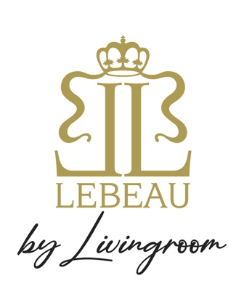

Try our Fresh Cocktail Lebeau Belgian Aperol Spritz

SUGGESTIES:

1x 6 Gillardeau oester €36

Cavaillon meloen met rauwe ham “Tamworth” €29

-----

Zeeuwse mosselen “Goudmerk” met groene tuinkruiden €27/€38

-----

Cold Roastbeef tenderloin & pickles-mayonaise €39

-----

Mystère au Grand-Marnier €15

BEEFBAR SELECTION:

Holstein “Dark red” Ribeye selection € 52pp

Ribstuk “Polderkoe” €49pp

Zesrib “Rubia Gallega” € 58pp

WIJNSUGGESTIES:

Wit: Mandolé Zwitserland Chardonnay €65

Wit: I’lle de Porquerolles 2022 Provence €65

Rosé: Chateau de Pibarnon France, Bandol €95

Rood: Saumur-Champigny 2022 France €50

Rood: Chianti Classico Sangiovese Toscane €70