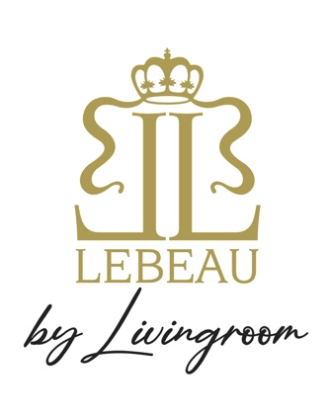

Try our Fresh Cocktail Lebeau Belgian Aperol Spritz

SUGGESTIES:

1x 6 Gillardeau oesters €36

Mini loempias “Peking duck” €24

-----

Burratina & onze tomaten van de Kapelhoeve €28

-----

De beste Zeeuwse mosselen “Blackwell” €27/€38

-----

“Knokkepoot” €15

Scropino “Jojo” vanaf 2pers. €16pp

BEEFBAR SELECTION:

Holstein “Dark red” Ribeye selection €52pp

Ribstuk “Zwin Polderkoe” eigen kweek €49pp

Zesrib “Rubia Gallega” zuiver ras €58pp

WIJNSUGGESTIES:

Wit: “Cigalus” Gerard Bertrand, France Chardonnay €80

Wit: Clos La Lanterne, Vouvray, Chenin Blanc Sec Gamberi €55

Rosé: Château de Pibarnon France, Bandol €95

Rosé: Château Simone, Palette €80

Rosé: Château Saint-Maur, Côtes de Provence €95

Rosé: Gérard Bertrand “Clos du Temple”, Languedoc €150

Rood: Saumur-Champigny 2022 France €50

Rood: “St. Daniel Riserva” Pinot Nero €80