Info booklet

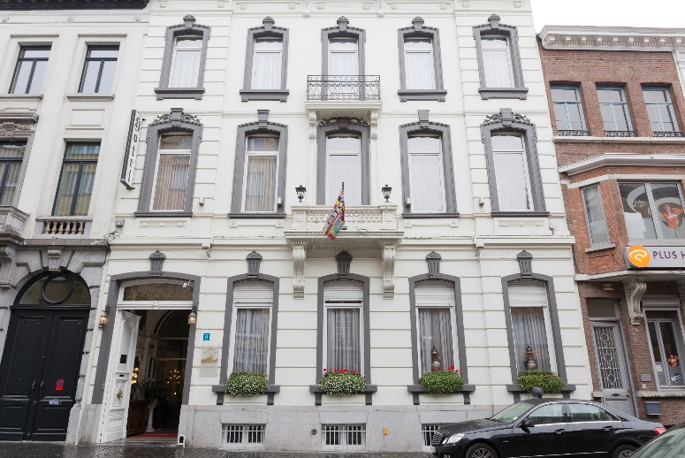

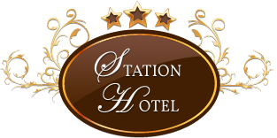

Station Hotel Aalst

Bvba Quintijn-Janssens

Station Hotel 

Albert Lienartsstraat 14

B-9300 AALST

Tel. 053 77 58 20

Fax 053 78 14 69

E-Mail: [info@stationhotel-aalst.com](mailto:info@stationhotel-aalst.com)

www.stationhotel-aalst.com

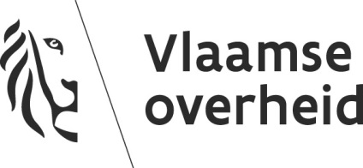

**DEPARTEMENT INTERNATIONAAL VLAANDEREN**

Dienst Toeristische vergunningen

Boudewijnlaan 30 bus 80

1000 BRUSSEL

TEL: 0032 2 553 29 50

E-mail: [logies@iv.vlaanderen.be](mailto:logies@iv.vlaanderen.be)

**Het Departement internationaal Vlaanderen is de bevoegde instantie die de vergunning toekent en waar verdere informatie verkregen kan worden over de reglementering inzake de exploitatie van toeristische logies en de rechtsmiddelen die algemeen voorhanden zijn bij geschillen en waar de toerist een klacht kan indienen.**

**Le Département des Affaires étrangères de la Flandre (Departement internationaal Vlaanderen) est l’instance compétente qui octroie le permis touristique et auprès de laquelle de l’information supplémentaire peut être obtenue sur la réglementation en matière des hébergements touristiques et les voies de recours généralement disponibles en cas de litige et auprès de laquelle les touristes peuvent introduire des plaintes.**

**Das Departement internationaal Vlaanderen ist die für die Erteilung der Genehmigung zuständige Behörde, wo man weitere Informationen über die Reglementierung bezüglich des Touristische Unterkunftsbetriebe und die im Streitfall allgemein verfügbaren Rechtsbehelfe erhalten kann und bei der Touristen eine Beschwerde einreichen können.**

**The Flemish Department of Foreign Affairs (Departement internationaal Vlaanderen) is the body competent for issuing the touristic permit and where any further information can be obtained on the regulations regarding the operation of a tourist accommodation and the legal remedies that are generally available in case of disputes and where tourists can file a complaint.**

**WI-FI CODE**

**Log-In: StationHotelGuest**

**Password: StationHotel1302**

Table of contents

•Welcome

•Practical information   
•Facilities  
•History  
•About Aalst  
•Location  
•Activities  
•Appendix

Official welcome

Welcome to Station Hotel Aalst ...  
  
Station Hotel Aalst is housed in a unique building that dates from the second part of the 19th century.  
The hotel has fifteen rooms that are decorated according tot the atmosphere of the hotel (six single rooms, eight double rooms and a triple room). All rooms are equipped with a minibar with free water, a flat screen TV, coffee and tea.  
  
  
Our hotel is located near Aalst train station and within walking distance (about five minutes) from the lovely city center, which is characterized by four large shopping streets and the market square (Grote Markt).

Let yourself be pampered in our hotel again or enjoy an exceptional mini-break in Aalst.  
  
Cycling, walking, exercising, enjoying good food and the culture of the city. It is all possible in this beautiful environment.

You can use our honesty bar to enjoy wines, beers and soft drinks.  
  
Your stay starts with us, you are most welcome!   
  
Don't forget to leave a review after your visit about your satisfaction on our website after or during your visit.  
  
  
Station hotel & staff

Practical information

Check-in/check-out  
Check-in from: 15 to 22 o’clock  
Check-out: 07 to 11 o’clock  
  
Breakfast  
Continental breakfast buffet is served daily in the following hours.  
In the week from: 07 to 10 o’clock  
In the weekend of: 08 to 10.30 o’clock  
You can find the breakfast room on the 1st floor. The price is not included in the room rate.  
Breakfast can be selected during the booking process as "extras" after you have entered your data. Or the night before.  
  
Cancellation policy  
Below you will find the conditions that apply in case of cancellation. The amounts and percentages shown must be paid by you.  
The special conditions have priority over the generic when applied.  
Generic conditions (individual booking)  
 • Less than 48 before date: 100.00%  
  
Special conditions  
Non refundable  
 • Please note: if you cancel or change the booking, or you do not show up, the full cost of your reservation will be charged.  
Groups *  
 • Between 7 and 0 day (s): 100.00%  
(*) Groups: Each booking for 3 rooms or more  
  
Payment  
The hotel accepts Visa, MasterCard, Maestro and American express  
. If you require an invoice please state your company name and VAT number at check-in. In this way we can ensure a smooth checkout. Contact front desk  
Dial the number 11 with the fixed telephone in the room.  
The mobile phone on the number: + 32 53 77 58 20

Practical information

Honesty bar  
Station hotel offers you the possibility to pour the perfect drink in our honesty bar.   
Our honesty bar is located at the back of the salons.  
After consuming a drink, write this on the provide leaflet together with your room number and date.  
Please leave your sheet at the reception so that this can be added to the invoice.  
The honesty bar is open 24/24 and 7/7.  
  
Smoking facilities

It is not allowed to smoke in the building and in the rooms. If you want to smoke, you can do this in the back of the garden. If you fail to comply with the smoking ban, you will be charged an extra € 200.

Pets  
Pets are not allowed.  
  
Internet in the hotel/Wi-Fi  
Our hotel has free Wi-Fi throughout the building.

Login: StationHotelGuest  
Password: StationHotel1302  
  
Door opening hours hotel  
The doors are open from 6 to 22 o’clock.  
If you arrive before or after opening hours, you must use the code you received at check-in.  
You can also just ring the Bell in case of problems.  
To leave the hotel with the door locked, press the unlock switch to unlock.

Facilities

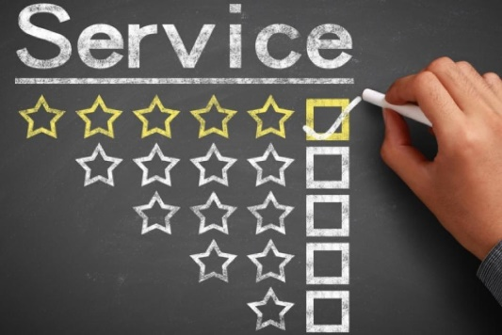Services available on request at the hotel:

* A rain cover
* An international plug adapter
* An adjusted gluten-free diet on request
* Baby bed available for free
* Baggage service
* Copy / scan service
* Different telephone chargers
* External service (Visits, Tickets, Taxis)
* Laundry and ironing service (ready as agreed)
* Snacks available for a fee Use of fax and laptop
* Sewing tools / shoe polishes
* Toot brush set / shaving set
* Use of ironing board and iron
* Wake up service

Facilities in the hotel:

* Bicycle storage
* Bicycle rental nearby
* Courtyard / Terrace
* Free WIFI • Honesty bar
* Generous continental breakfast
* Secure storage space for luggage
* Reception service at the hotel from 7 am to 11 pm
* Shoe polish machine in the entrance hall
* The entire hotel is non-smoking

Facilities in the rooms:

* Air conditioning in some rooms
* Flat screen television
* Free wireless internet
* Free water bottles, coffee and tea
* Heating
* Hair dryer (you can find it in the bathroom furniture)
* Non-smoking   
  (in the case of non-compliance, a fine of €200 will be charged).
* Phone
* Safe
* Smoke-free (fine of € 200 will be charged for non-compliance)

History Hotel

This building dates from the early nineteenth century. The first resident was Charles Druwé (commercial judge). He sold the building to Prosper Van Ginderdeuren who had a factory in the street. In the garden a shelter was found, possibly from German officers. When the building was empty, a guesthouse came for boys. And eventually it became this hotel. As a result, many original details from this era remained in honor and there are still many of the authentic elements left in our hotel. A wonderful example of this is our entrance hall.

Another feature from this time is our lounge which is still completely preserved with the unique Baroque style. The entrance is easy to recognize with its 2 Lions doorknobs and the beautiful sculptures in it.  
  
Throughout his glorious history the hotel received 3 stars for our good service and hospitality. Also, we have our regular customers that are sure of our hotel. For the new clients, we hope that they find it pleasant here and even want to come back to this little gem.

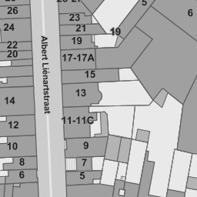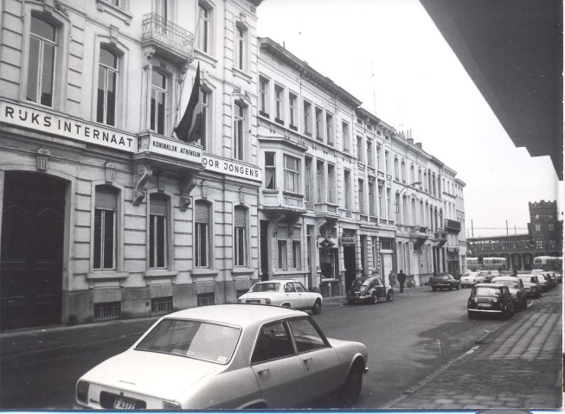

About Aalst

Aalst is the second largest town in the Belgian province of East Flanders. The city has more than 85,000 inhabitants (2018), which are called Aalstenaars. Aalst is famous for its Carnival. St. Martin is the patron saint of the city. Aalst is located on the river Dender.  
  
Aalst is most famous for its annual Carnival and the statue of Dirk Martens in the middle of the main market square (grote markt). Dirk Martens printed the first book (Utopia) with separate letters in Dutch language; He was friends with Erasmus.  
  
An equally famous scion is the novelist Louis Paul Boon. Aalst also made a piece of Belgian political history in the beginning of the 20th century with priest Adolf Daens (brother of Pieter Daens) as the central figure, about whom Louis Paul Boon, incidentally, his most famous book "Pieter Daens or how in the 19th century Aalst workers fought against poverty and injustice "(1971) wrote. It embodies the social history of a city, region, people and era.

Aalst earlier thanked its prosperity to, among other things, hop growing. Typical Aalst hops are Green Belle, Coigneau, White Rank and Loeren. The Cathedral of Amiens was the example for the Aalst Sint Martinus Church, which was not completed. The original belfry of Aalst dates back to the 13th century. The current belfry is largely from the 15th century.

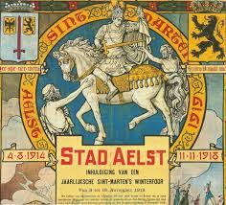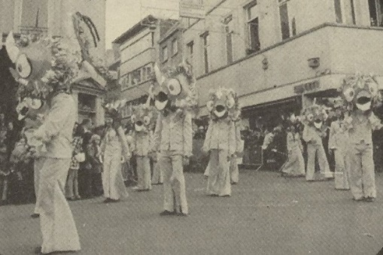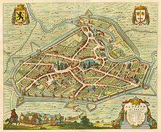

About Aalst

Parking  
Parking garage Post site (vaartstraat 18/Extra charged)  
Parking garage Ridderstraat (Ridderstraat/Extra charged)  
Parking Esplanadeplein (Esplanadeplein/100 places)  
The rates you can ask at the reception.  
  
Seeing & Doing  
In Aalst, we have a lot of fun hiking trips such as:  
WOI walking tour  
IPad-walk  
Nature walk  
City game/children's tour  
Quests/children's searches   
Workshops  
Are you interested in this fun hikes, here you will find more information about it. https://www.visit-aalst.be/nl/wandelen.  
  
You can also explore by bike such as Aalst:  
Utopia visit  
Belfort visit   
Park concerts   
Picnic in the Green  
Adventure park in Aalst  
The Brabant route  
Are you interested in this fun bike tours, here you will find more information about it. https://www.visit-aalst.be/nl/fietsen.  
What should you surely have seen if you go to Aalst!  
Belfort inside out, 't Gasthuys City Museum, the Saint Martin’s Church

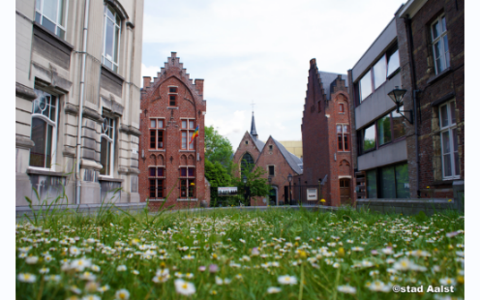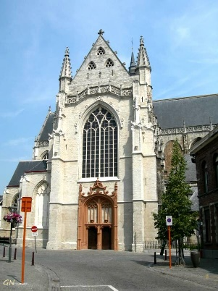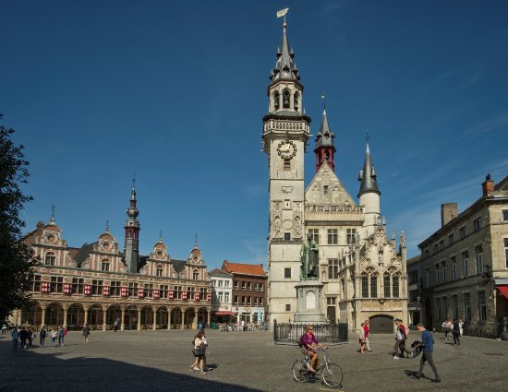

About Aalst

Eating & drinking  
Are you interested in nice places to eat and drink; you can request them in the tourist office or on https://www.visit-aalst.be/nl/bezoek-in-groep/eten-en-drinken-in-groep.  
  
you can taste the specialties at the local dealers in Aalst.

Events   
See here the following activities that you can do:  
-Utopia  
-Belfort  
-St Maarten Village  
-Year market  
-DNAalst  
-Peace tree Plantation on yard square  
-Carnival fair  
-Sports gala  
-Park concerts  
-Aalst Carnival  
Are you interested in more great activities, then they can also be viewed at: <https://www.aalst.be/evenementen>.

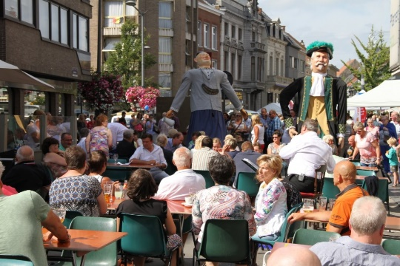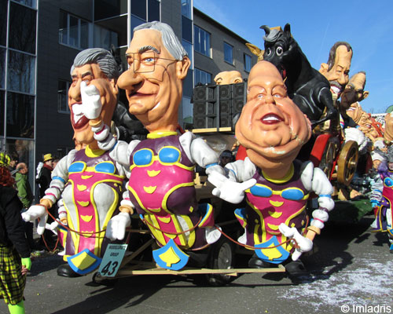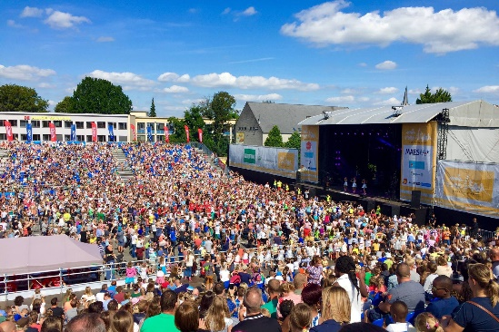

Activities

In Aalst there are several activities to do. We listed them here for you at:  
-DNAalst.  
-Children's art camp dance through the city  
-Unfinished landscape 100 years great war  
-History of Aalst  
-Nature walk  
-Sports activities  
-Workshops  
-City waves   
-Shopping  
-Music   
Are you interested in more, you can find even more activities via this website: <https://www.aalst.be/uit-in-aalst>

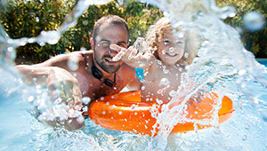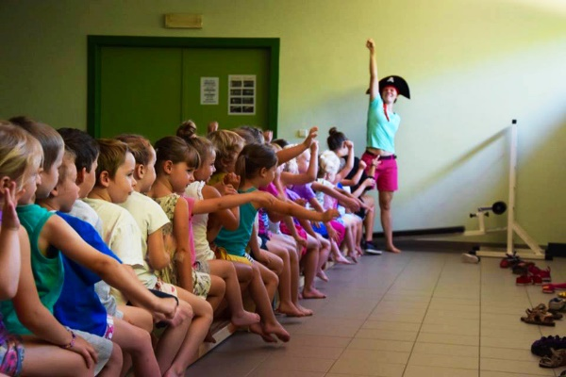

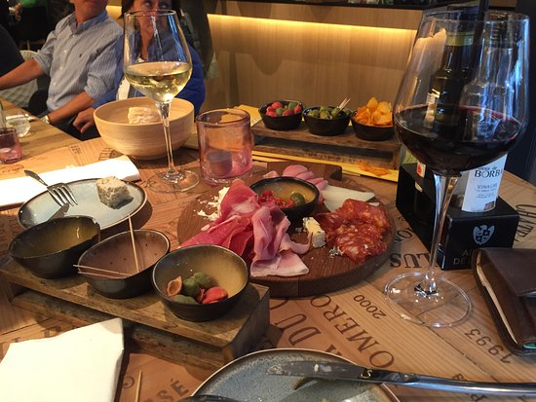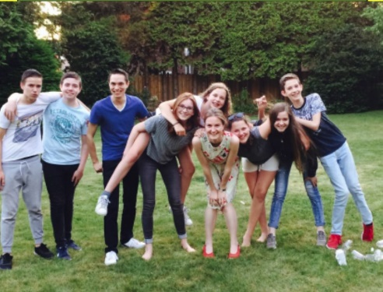

Bijlagen

Appendix

Annexe

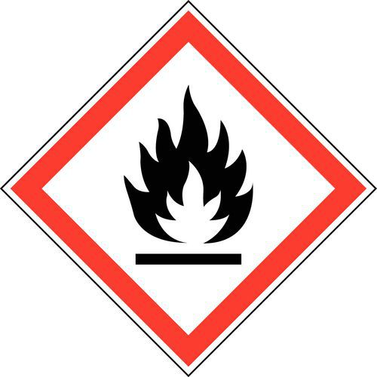

AT FIRE ALARM ALWAYS  
LEAVE THE BUILDING IMMEDIATELY BY THE STAIRS  
  
  
CAREFULLY READ THIS NOTICE!  
  
It is forbidden to transport or use objects or liquids that present a fire hazard. The electrical installation cannot be touched, to be modified or changed, without permission from the Management. It is strictly forbidden to smoke

in the entire building, to throw cigarette ends in the paper basket or out of the window. Explore the evacuation route and the emergency exit closest to your room. This can be found on drawings in all the rooms and corridors on each floor.

WHEN YOU DISCOVER FIRE!  
Pass the warning on. The warning button closest to your room is in the hallway.

WHEN YOU HEAR THE ALARM!  
  
Immediately leave your room and join the assembly point in the hall, past the nearby exit, front or back door. Another possible way is the roof. Close the door of your room, but also all the other doors you meet on your way. Do not use lifts to go outside. Do not shout or run this can only cause panic.

FIRE IN CORRIDORS, STAIRS, ETC.!  
  
Try not to escape when corridors and stairs are filled with smoke. Stay in your room, close the door, and close the door gap at the bottom with a damp cloth. Report your presence to the window.

**B.V.A. Fire Protection**

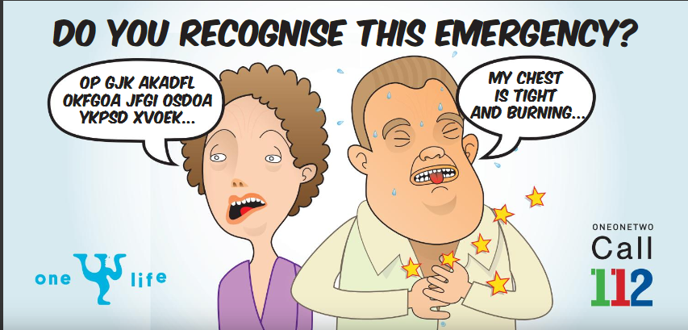**DOCUMENT 112**

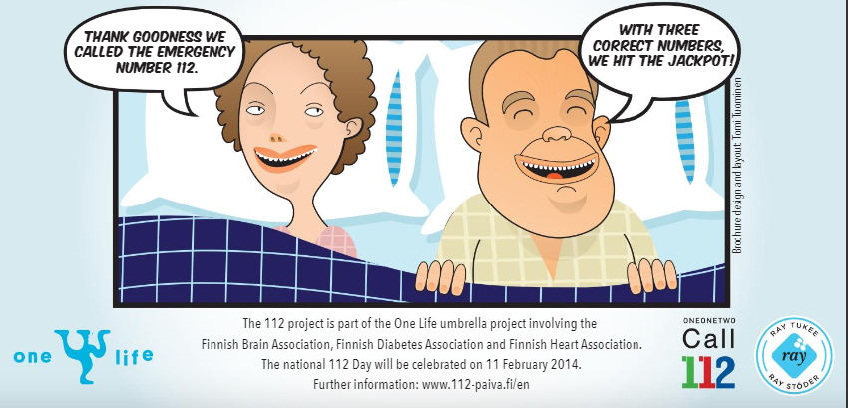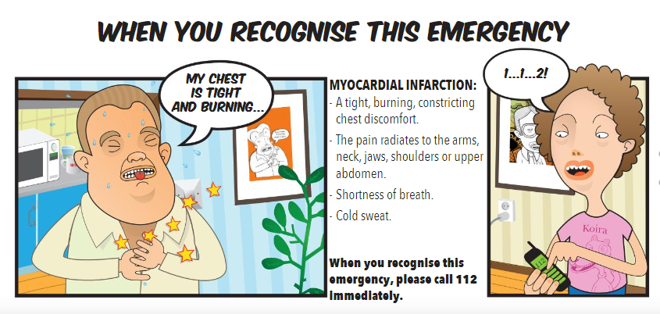

Health aid

If you have a health problem, you can certainly go to the following addresses. Or if you have an emergency you can consult these addresses.  
  
OLV AALST HOSPITAL  
Moorsel 164, 9300 Aalst course  
Tel. 053 72 41 11  
  
Mill-campus Aalst  
Merestraat 80, 9300 Aalst  
Tel. 053 76 41 11  
  
Family practices  
-Baker Jean-Pierre  
 Tel. 053 70 54 22  
 Field Street 14, 9300 Aalst  
-Family practices Cockx  
 Tel. 0475 28 68 52  
 Babatunde place 1, 9300 Aalst  
-Davids/Michel  
 Tel. 053 21 14 80  
 Stationsstraat 29, 9300 Aalst  
  
House doctors on duty  
 General HWP Region Aalst  
 Tel. 0900 69 018  
 Leopoldlaan 44, 9300 Aalst  
  
Important numbers

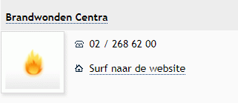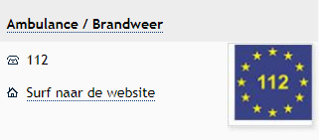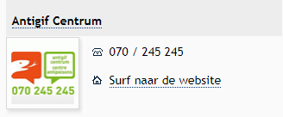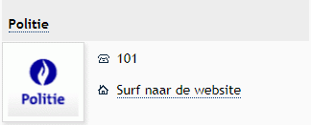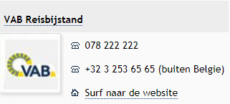

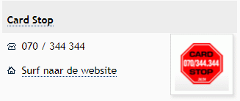

Station Hotel

Land numbers:

Germany: 0-00 49

France: 0-00 33

Italy: 0-00 39

Luxembourg: 0-00 352

Netherlands: 0-00 31

Portugal: 0-00 351

Spain: 0-00 34

Great-Britain: 0-00 44

Zwitzerland: 0-00 41

USA: 0-00 1

Station Hotel

Albert Lienartstraat 14

9300 AALST

Tel. 00 32 53 77 58 20

Fax 00 32 53 78 14 69

Email: [info@stationhotel-aalst.com](mailto:info@stationhotel-aalst.com)

<https://stationhotel-aalst.com>

Phone instructions:  
-for the reception, press the number "11".  
-To obtain an outside line, press the number "0".  
-The code for international calls, press the number "00".  
-Ex..: 0 + 00 + country code + phonenumber.  
-Emergency Medical Service and fire brigade pressure number "112"  
-Police pressure number "101"

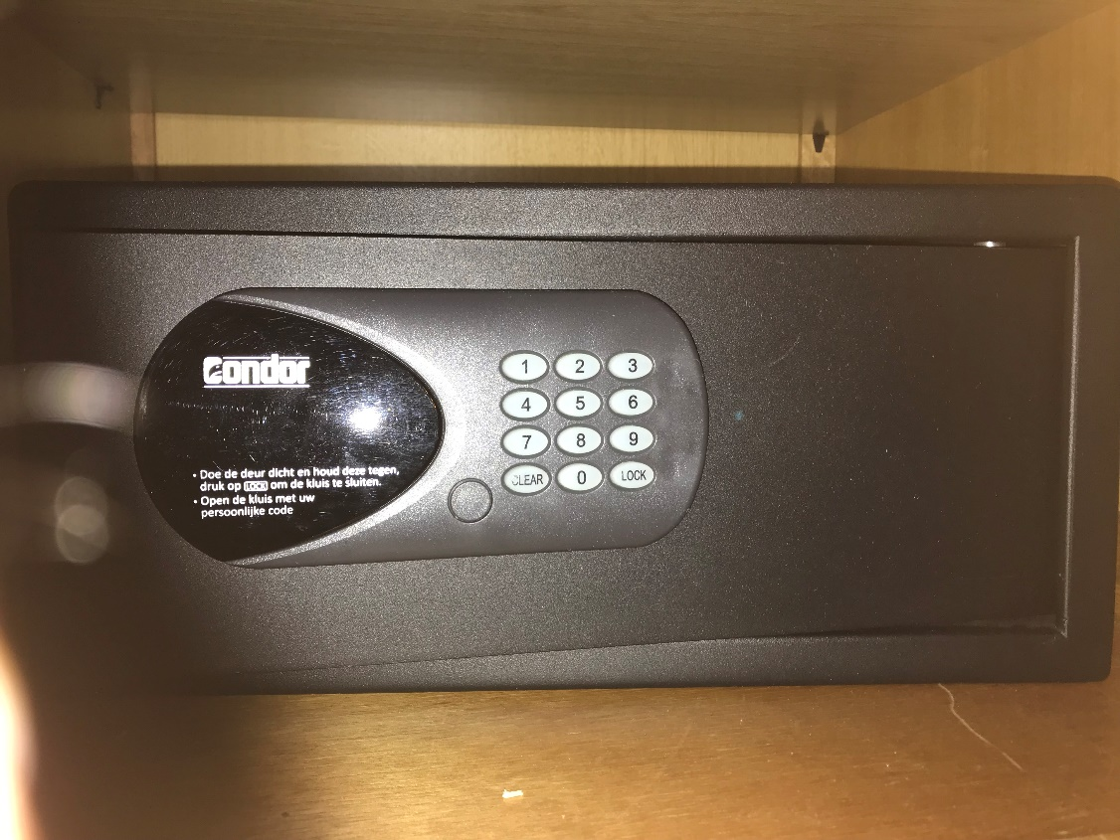

Set up a personal code

To enter a personal code, the safe must be open. (This means that the bolts must be retracted). ⎫ Press the "**CLEAR**" button twice, the text "**PROG**" will appear on the screen, enter the code "68". ⎫ Then press the "**LOCK**" button so that "**NEW**" appears on the screen and enter a new 4–6-digit code. ⎫ Then press the "**LOCK**" button again, "**AGAIN**" will appear on the screen, enter the new code again and press the "**LOCK**" button. "**DONE**" will appear on the screen, the new code will be displayed. successfully set.  
  
To open the safe with a personal code

Enter the personal code (pre-programmed 1-2-3-4). The door will open automatically. ⎫ If a wrong code is entered, "**ERROR**" will appear on the screen. ⎫ If a wrong code is entered 4 times, the system will switch to safe mode. The text "**HOLD15**" will appear on the screen. This means that the keyboard is blocked for 15 minutes to prevent illegal activities.  
To Close the safe

Close the door, press the "**LOCK**" button. The door will close automatically.

**Caution**: If something blocks the door, "**ERROR2**" will appear on the screen and the bolts will retract automatically. Remove obstruction and try again. If a wrong number has been entered, press the "**CLEAR**" button.

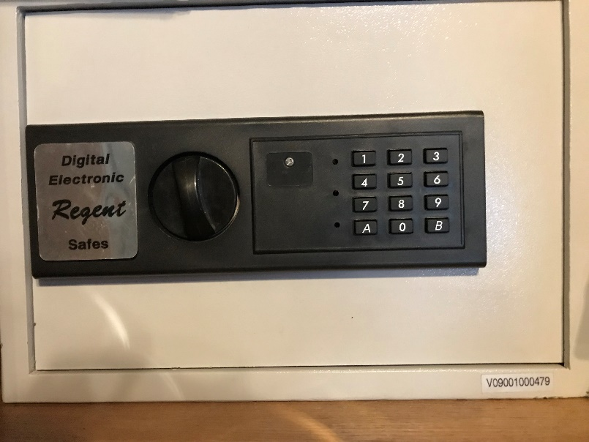

To program your own code

-Press the red button on the inside of the door.  
-the yellow light comes on and you hear 2 beeps.  
-the old code has now been deleted.  
-bring your personal code of minimum 3 and maximum 8 digits and press B to confirm.  
-leave the door open and test your new code by entering in the code, followed by A.  
-turn the knob clockwise on the outside. The safe is now ready for use.

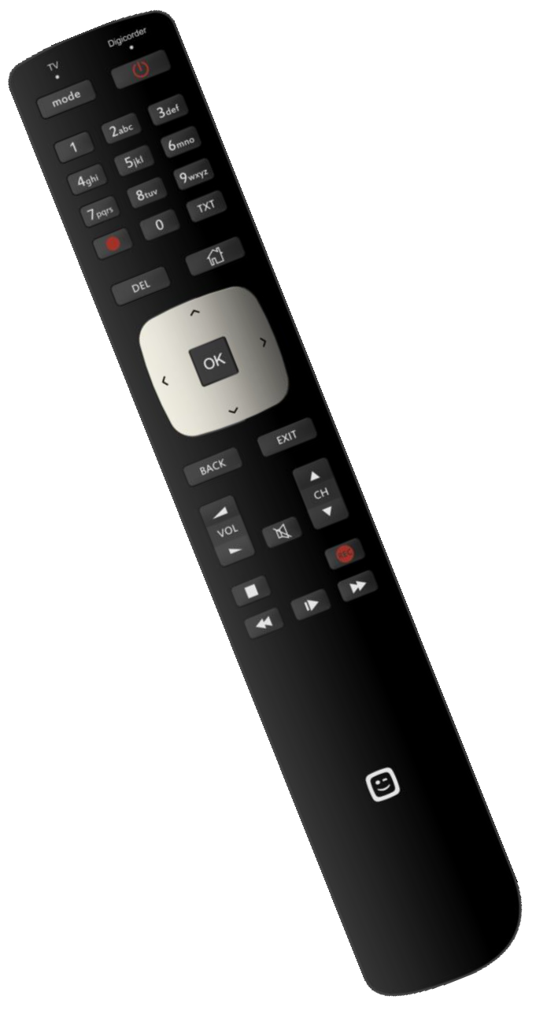

How can I turn the TV on!

1)To turn TV on press 

Untill the led turns on below inscription TV on the remote control.

2)Push de  button to turn the TV on.

3)Use the 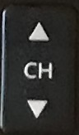 button to select the

Right channel HDMI1

4)Puch again on the  button Untill the led turns on below inscription DIGICORDER on the remote control.

5)Puch on the  button to turn the DIGICORDER on.

Honesty bar

Koffie of Thee € 2,00

Chaudfontaine blue € 2,00

Chaudfontaine red € 2,00

Coca Cola € 2,00

Coca Cola Zero € 2,00

Ice Tea € 2,00

Fanta € 2,00

Jupiler 25cl € 2,00

Duvel 33cl € 3,00

Chimay 33cl € 4,00

Westmalle 33cl € 4,00

Leffe Donker 33cl € 3,00

Leffe Blond 33cl € 3,00

White Wine 25cl € 5,00

Red Wine 25cl € 5,00

Rosé Wine 25cl € 5,00

White Wine 75cl € 15,00

Cava 20cl € 7,00

Cava 75cl € 20,00

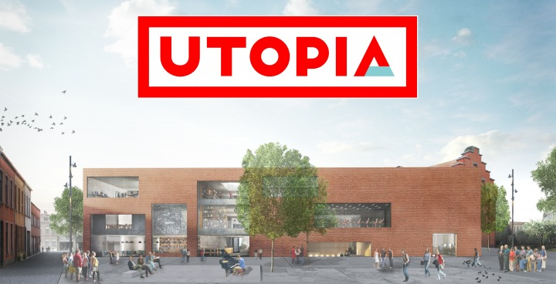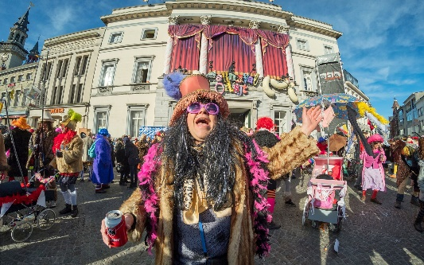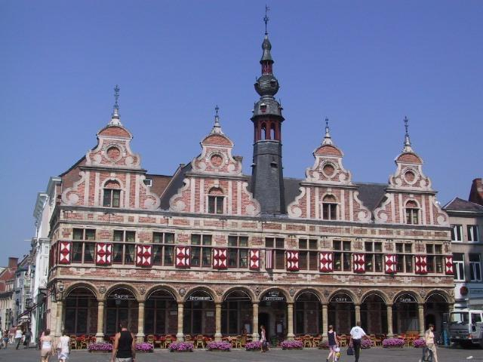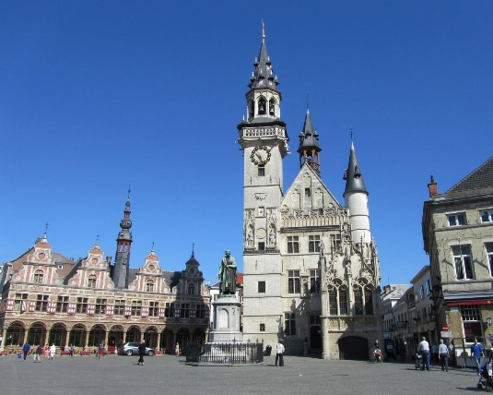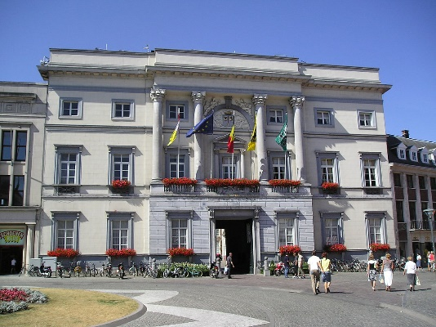

A Pleasant

We wish you

Stay!

Note sheet

------------------------------------------------------------------------------------------------------------------------------------------------------------------------------------------------------------------------------------------------------------------------------------------------------------------------------------------------------------------------------------------------------------------------------------------------------------------------------------------------------------------------------------------------------------------------------------------------------------------------------------------------------------------------------------------------------------------------------------------------------------------------------------------------------------------------------------------------------------------------------------------------------------------------------------------------------------------------------------------------------------------------------------------------------------------------------------------------------------------------------------------------------------------------------------------------------------------------------------------------------------------------------------------------------------------------------------------------------------------------------------------------------------------------------------------------------------------------------------------------------------------------------------------------------------------------------------------------------------------------------------------------------------------------------------------------------------------------------------------------------------------------------------------------------------------------------------------------------------------------------------------------------------------------------------------------------------------------------------------------------------------------------------------------------------------------------------------------------------------------------------------------------------------------------------------------------------------------------------------------